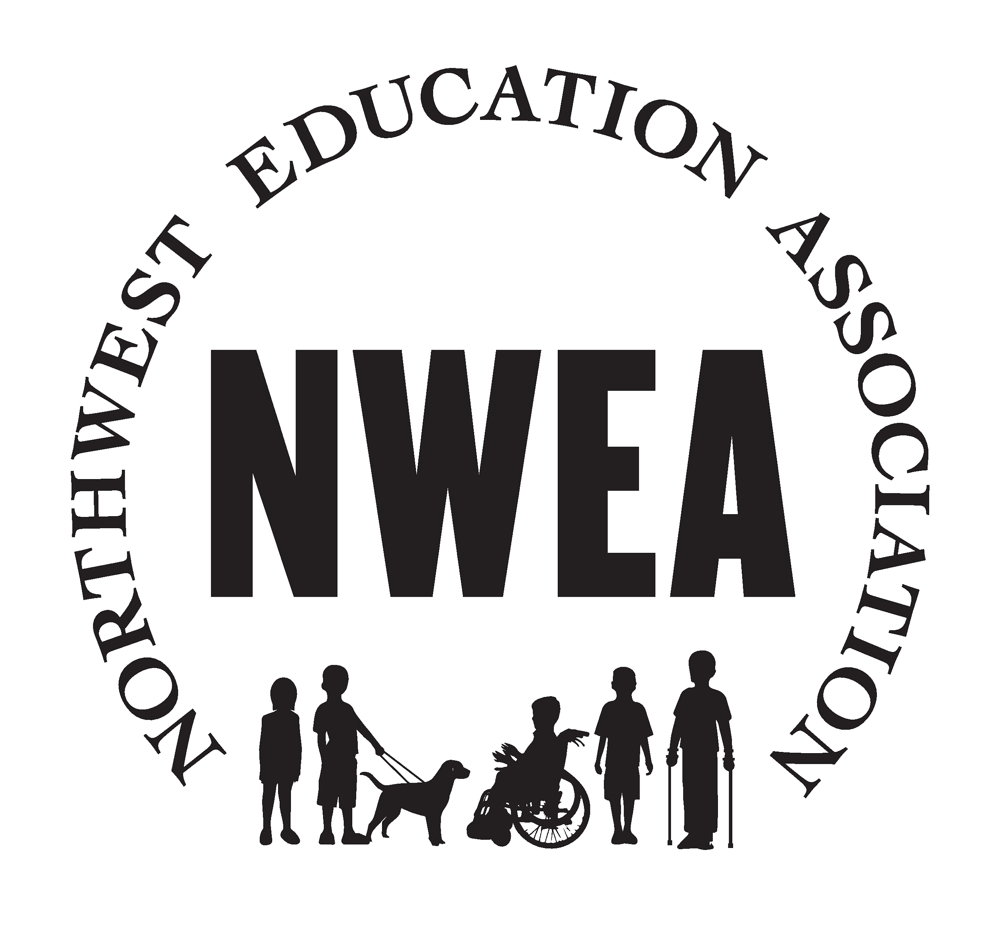
October 16 , 2020

NWEA NEWSLETTER
https://www.nweducators.org/
This month's newsletter you will find:
- Workshare update, unemployment resource, wellness tip of the month, a raffle opportunity and how to get involved

What the union is working on this month:
- Workshare- NWEA board members have continued to work on contacting licensed staff to get information to support workshare claims. This was a BIG task, but we reached most members. We know people are still waiting, but claims are continuing to be processed! If you need help, you can reach out to your building rep or union board members
- Unemployment-If you need help to track your claims or get information about where your funds have been dispersed (ReliaCard, Direct Deposit or Check) please visit: Oregon Unemployment. From this site, select “status of initial claim and other account details. You will be able to create a log-in to track the status of all of your claims. The system is updated once per day.
- Back to School- Your union president meets weekly with the back to school committee. There has been a lot of discussion about cleaning procedures. If you have concerns about your work site’s cleanliness or cleaning procedures, we encourage you to reach out to your supervisor.
Wellness Tip(s) of the Month
- We care about you and want to make sure we each take a moment for some self care! This month’s Wellness tip is brought to you by Tina Weeks in Tillamook. She recommends Yoga by Adriene. It's available for free on youtube and can be a great exercise for your body AND mind! Check it out here: Yoga by Adriene

Raffle Time!
- What has the union done for you? We’d love to hear your stories! Follow the link to submit and you’ll be entered to win one of our 4 gift cards! Can’t wait to hear from you!Union Survey
Donation Made for Oregon Students
- Your union is always looking for ways to support the community we serve. This month the board voted to make a donation to OEA to fund grants for students impacted by the Oregon Fires. The donation will be sent to the organization within the next week.
Swag Bag!
- SWAG BAGS are coming your way! Your union board wanted to take a moment to say how much we appreciate each and every one of you! We have put together a little gift that will be arriving at your work sites. For Washington County sites, your bag will be delivered by courier to your work sites, for staff working out of Columbia, Tillamook and Clatsop counties your bag will be delivered to your local service center. They should arrive by November 3rd!

Board Member Spotlight!
We want to introduce each of our board members so you can get to know us better! We will spotlight a board member each month. Let's start with Sarah Andrews, your union President!
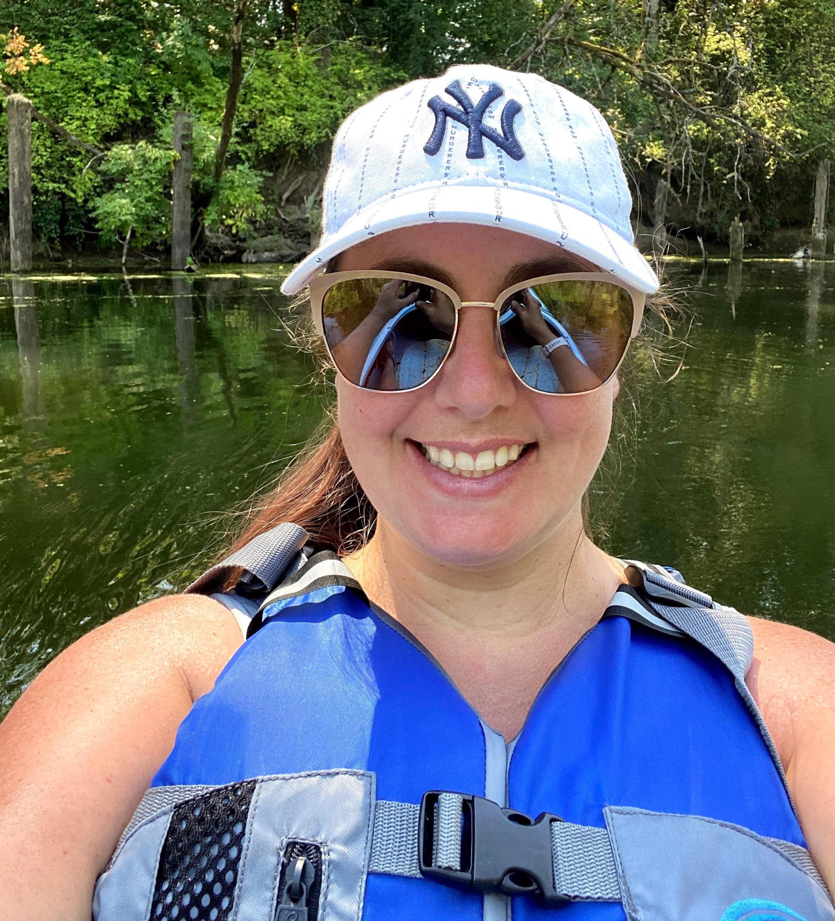
Sarah Andrews has worked at the ESD for 12 years as a special education teacher. She started her career in the early childhood special education program at the Beaverton Early Childhood Center then joined the early intervention team at Hillsboro Early Childhood Center. In a normal year she would be spending TONS of hours at the baseball field, but this year she and her son are getting more time to Kayak, explore lakes, and do puzzles! She just received her certification as an Autism Specialist and is now working towards her initial administrators license! This is Sarah’s third year serving as your union president! Thank you for all your work, Sarah!
Want to get involved? You can be a building representative, join this year's bargaining team, actively participate in your union! Reach out to a union board member to find out how. Suggestions or questions? Email your union at contactus@nweducators.org

You are all amazing!

